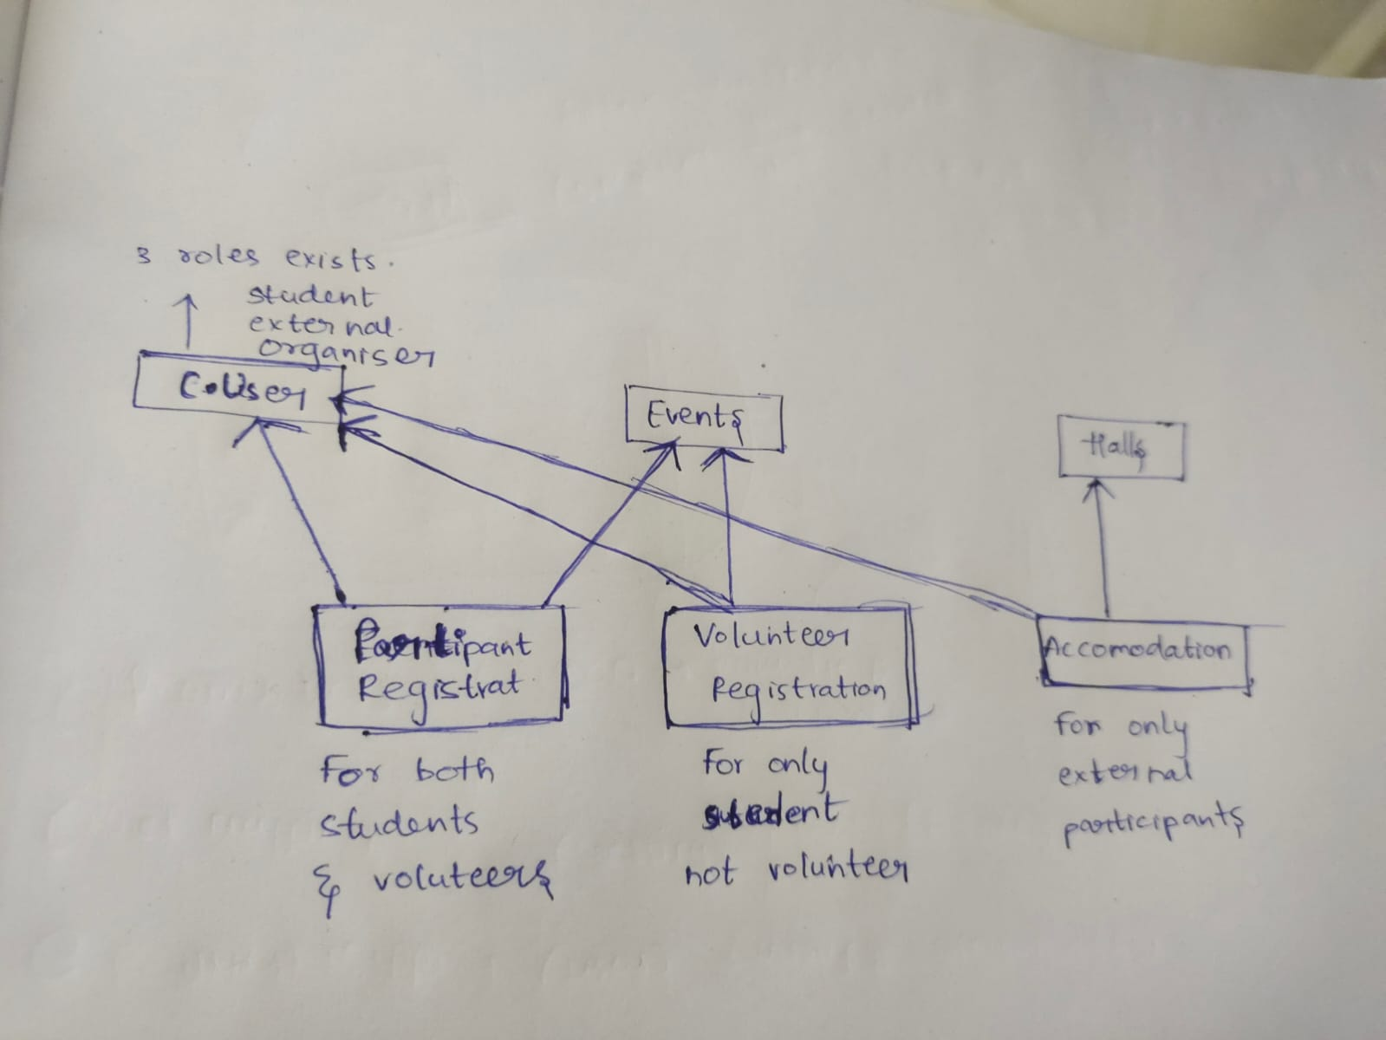

shiva@gmail.com = student
vijaygovind@gmail.com = external
sam@gmail.com = external
allu@gmail.com = organizer

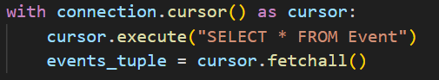

Problem statement:
Develop a Web application using Django following integrity and consistency of the database.
Completely done using SQL without using django ORM in order to gain hands on experience with SQL and
to make operations on database more flexible

Three types of registrations:
student, external, organizer

same login for all, according to his role he will be redirected to appropriate dashboard

student:
After successful login, list of events are displayed
participates or volunteers the events

external:
After successful login, list of hostels details, their vacancies, prices, and pictures will be displayed he can opt some particular hostel for accommodation
And list of events were displayed so that he can participate

Organiser:
He is like the head of the fest
he can remove students, external participants from the fest
He can see details of events and can remove participants and volunteers from the event

Now say about how we are maintain integrity and consisensy of the database:
integrity:
1.while registering:
password==confirm password
checks whether user already present in custom user (first 2 points are geezz)
for student registration checks whether mail ends with @iitbhu.ac.in

2.Student:
cannot register multiple times for an event
cannot volunteer multiple times for an event
cannot be both participant and register for an event
cannot participate or volunteer for multiple events at same time

3.External participants:
cannot register multiple times for an event
cannot participate for multiple events at same time
cannot have accommodation in multiple hostels
during accommodation checks whether vacancy of hostel>0

Consistency:
1.External participants:
after successful accommodation vacancy of hostel decreases by 1

2.Organizer:
When deleting a student, dependent tables like customuser, eventregistrations, volunteer are also cleaned
When deleting an external dependent tables like customuser, eventregistrations, accomodations are also cleaned and vacany of hall increases by 1 if he have any accommodation
Deleting event particiants and volunteers is direct

Main views:
student registration
participation registration
Hostel booking
Delete student, Delete external
Delete_event_particant/ external

Tables: (remember ERD)
Custom user events halls
Participant registration volunteer registration

Difficulties:
As it is starting point of my web development journey. Learning Django and SQL is difficult.

Difference between python manage.py migrate and python manage.py makemigrations:
Migrate:
Detects changes in your models.py and creates a migration file.
Makemigrations:
Applies migrations to the database

What is the use of Django middlewear?
It is similar to filters in spring.
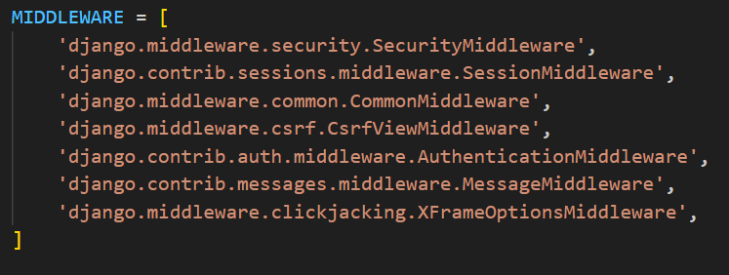
Manages security authentication.
Manage sessions.
Manage csrf protection.

Difference between wsgi and asgi?
wsgi = synchronous communication between client and server.
ie sender blocks until the message reaches receiver.
Ex: Simple webserver giving request and getting response.

asgi = asynchronous communication between client and server.
Ex: Hotstar (we get continuous video streaming)

